OSUL User Priorities Survey
Administered March 7-31, 2017
320 responses

Recruitment:
Due to university restrictions, we were unable to do a “campus wide” broadcast for participants, but were able to work through existing relationships. Participants were invited through inserts in books picked up from circulation desks in all locations. Invitation messages were sent directly to lists of people who had attended workshops for first- and second-year students for the past 2 years (undergrads), participated in Research Commons events (mixed audience), or signed up for research tutoring (undergrads). Specialist librarians (subject, departmental, Area Studies, and special collections librarians) and regional campus librarians (Lima, Mansfield, Marion, Newark, and Wooster) wered asked to forward invitations to their contacts.
Incentive: Participants were entered into a drawing to win one of four $25 Target gift cards.

1. What is your current role at Ohio State?
122 faculty
96 grad students
90 undergrads
12 other:
- 2 postdoctoral researcher / postdoctoral fellow
- 2 visiting scholar
- 2 professional student
- alum
- retired library faculty
- retired faculty
- staff member who is also a grad student
- Resident
- Program 60 (OSU program to offer courses to people over 60)
2. Why do you primarily use the library.osu.edu website? (open-ended question)
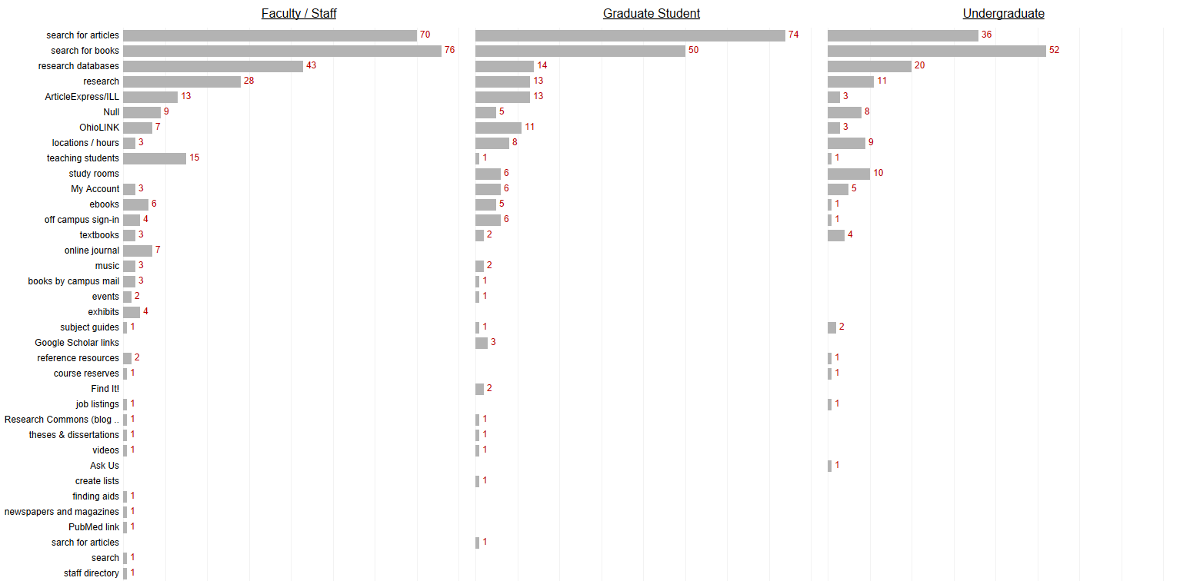

3. Thinking about how you use University Libraries, please rank the items…
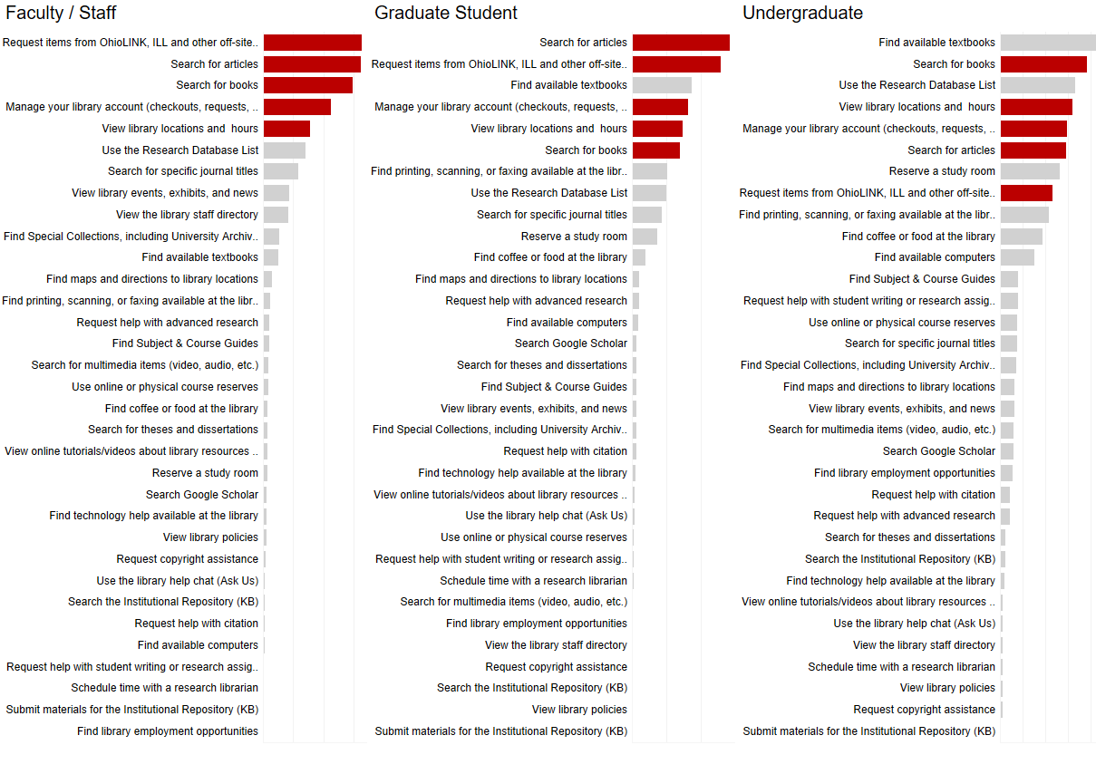

4. What do you LIKE about the current library.osu.edu website? (open-ended question)
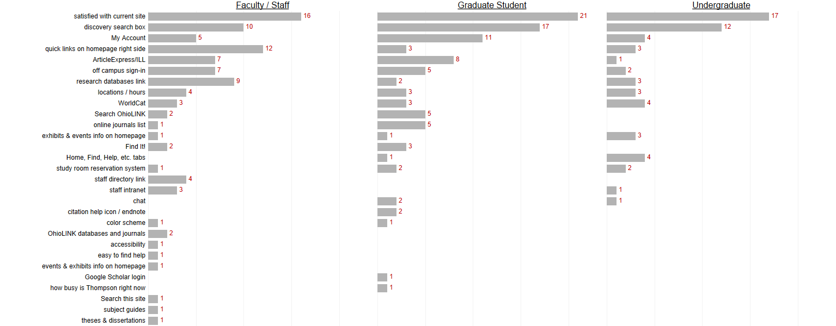

6. What do you NOT LIKE about the current library.osu.edu website? (open-ended question)
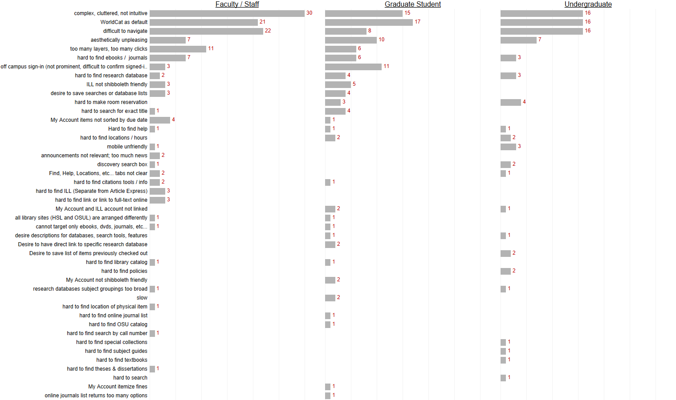

6. When you seek information for your research or assignments, which websites do you use? E.g., library.osu.edu, Google, Google Scholar, Wikipedia. Please provide as much detail as you can. (open-ended question)
Results not yet available

7. What device do you usually use to access the library.osu.edu website? Select all that apply:

 | Faculty/Staff | Grad Students | Undergraduates | Other | Total
Desktop | 75 | 37 | 19 | 8 | 139
Laptop | 74 | 76 | 74 | 9 | 233
Tablet | 24 | 13 | 7 | 4 | 48
Smartphone | 26 | 24 | 28 | 3 | 81
Multiple Selections | 44 | 44 | 39 | 7 | 134

